By Arabinda Chand

population strategist

Is population good or bad,Let’s see this dual edged knife(can be good or harmful as per usage) through my views!!

**MINI PROJECT**

Report on

**“POPULATION STRATEGIST”**

Submitted in partial fulfillment of the requirements of the degree

**BACHELOR OF ENGINEERING IN**COMPUTER ENGINEERING

By

**ARABINDA CHAND**

Guide

### Dr.Shital Agrawal



**Department of Computer Engineering**

**B R Harne College of Engineering and Technology**

**Karav, Vangani (W) -421503**

**University of Mumbai (AY 2024-25)**

**CERTIFICATE**

This is to certify that the Mini Project entitled **“POPULATION STRATEGIST”** is a bonafide work of carried out by his/her under the supervision of Prof. Shital agrawal, and it is submitted to the University of Mumbai in partial fulfillment of the requirement for the award of the degree of **“Bachelor of Engineering”** in **“Computer Engineering "..**

**(Prof. Shital Agrawal)**

Guide

**( Dr. Shital Agrawal ) ( Dr. Vikram Patil )**

Head of Department Principal

**Mini Project Approval**

This Mini Project entitled “**Population strategis**t**”** by **Arabinda Chand**is approved for the degree of **Bachelor of Engineering** in Computer Engineering **.**

**Examiners**

**1………………………………………**

(Internal Examiner Name & Sign)

**2…………………………………………**

(External Examiner name & Sign)

Date:

Place: KARAV

**Contents**

**Abstract ........................................................................................................................ 1**

**Acknowledgement ........................................................................................................ 2**

**List of abbreviations .................................................................................................... 3**

1. **Introduction ...................................................................................................... 4** 
   1. Introduction **4**
   2. Motivation **5**
   3. Objectives **5**
2. **Literature Survey ............................................................................................ 6-7** 
   1. Survey of Existing System **6**
   2. Limitation Existing system or research gap **6**
   3. Mini Project Contribution **6**
3. **Problem definition .......................................................................................... 7**
   1. Problem Definition **7**
4. **Proposed System .......................................................................................... 8-15**
   1. Architecture framework 8-**9**
   2. Algorithm **9-15**
5. **Planning And Time Estimation ................................................................. 16**
6. **System Requirement…................................................................................ 17**
   1. Details of Hardware  **6.2**Details of Software **17**

**System Design .................................................................................... 18**

* 1. Data Flow Diagram **18**

**6.4** Shared Preferences **18**

1. **Implementation ...................................................................................... 19**
2. **Testing…................................................................................................. 20-21**
   1. System Performance **20**
   2. Observation **21**
   3. Test Case **21**
3. **Result Analysis… ....................................................................................... 22-23**
4. **Conclusion And Future Scope .................................................................. 24**

# ACKNOWLEDGEMENT

There are times when words cannot express our gratitude. It is with us, as we cannot find appropriate words that would express our deep sense of gratitude and satisfaction. We would like to take this opportunity to thank everybody who helped through the successful completion of this project. Many people have contributed to our achievements during the project and we take this opportunity to thank each one of them at end of the project durations.

First, we would like to thank our Principal Sir, H.O.D & our project guide Prof.Shital Agrawal, who has extended all his valuable guidance, help and constant encouragement through the various difficult stages involved in the development of the project.

We would like to express our heartfelt thanks to all who contributed their valuable experience and knowledge and provided constant guidance to us. Thus, we feel fully obliged and convey our thanks to the teaching as well as non-teaching staff of the department. Last but not the least we would like to thank to our project partners(books) for their efforts and help.

Last but not the least we are thankful to our parent and friends for their constant Inspiration, encouragement and well wishes by which we have made a challenging project.

**Terms**

Agroecology-applying ecology concepts to design n develop agricultural systems

Acclimation-reversible physical adaptation

Abundance-number of organisms in a population

Demography-statistical study of populations

Age Structure-distribution among age groups

Adaptation-alternation of structure and function to respond to environment

Atmosphere-it has gases by earth gravity reataining heat n reflect UV,layers-troposphere,stratosphere,mesosphere,thermosphere,exosphere

Biodiversity-variety among plants & animals

Biome-climatically and geographically defined ecologically similar conditions community

Biosphere-sphere of life in living matter with two part-abiotic factor &biomes & relationships between lithosphere,hydrosphere,atmosphere

Climate-average weather of a place for long duration due to latitude terrain,altitude n water currents

Community-group of organism in same environment

Ecology-it’s scientific study of interaction of organism with one another n environment

Ecosystem-

Natural selection-process of survival of better adapted individuals

Migration-moving one place to other

Food chain-feeding relation from producer to consumer to scavenger to decomposers

**CHAPTER NO.01**

# INTRODUCTION

## 1.1Introduction:

**Bioinformatics has the same goal for biologists,that a computer has for mathematics & machine has for life which is finding patterns and efficiently do tedious and repetitive work,so that other focuses on higher and creative aspects of the field, So I want to formulate a program for our hardworking epidemiologists and ecologists**

**1.1.2Benefit:**

* It provides solution to your curated query about your demographics
* Pollution is directly related to population
* We can better understand to use natural resources judiciously
* Use for tracking diseases
* Used for tracking population resource flow

## 1.2Motivation:

I love biology due to love of zoos where I like to study animal behavior & watching superheroes while growing up, computer made place in my liking due to my fascination to explore new tech which I get on my hands & since I am a rapper too, languages makes a special taste for my buds, be it programming languages, I like anthropology due to my love of books where I discovered dinosaurs, I like stats as I love to find patterns which I discovered during my Olympiad prep days So after you got context of my interests, It’s time to delve deeper into understanding, how I stumbled upon this topic, I make small projects for the fun of it from my imaginary problems but one day I saw a video where developed countries not getting laborers because of population shortage which defied my initial beliefs that population leads to poverty before this I had seen that many bioinformatics job profiles need r after python which was new to me so I thought should try it, if it align to my goal, I tried a project but couldn’t execute it off completely ,so I found this a great opportunity to grind again for this project as normally projects are to nurture new ideas and creativity by incentivizing with marks

## 1.3Objectives

* To study patterns and trends in populationto predict future
* To categorize by identifying similar and different characteristics
* Understand demographics
* Better utilize human resources

**CHAPTER NO.02**

**LITERATURE SURVEY**

**2.1Survey of Existing System**

### Couldn’t find any similar system

### 2.2Mini project contribution -research,coding& ppt also report

### 2.3Limitation of existing system-Sorry,I couldn’t find something related to like my program on internet, But I’d like to shed some light on issues I faced while coding this as a coder which others can face too:

### It’s research intensive: It’s more research than coding. Since, ecology has biology,it requires scientific temperament and social science brings in many nuances to consider while epidemiology brings stats into picture which eventually pulls computer science into the game, requiring good formulation ability

### New field: Bioinformatics is a new field established in 2010’s for human genome project byUS,UK,France,Germany,Japan& China

### Infinity values: It gives infinite value many a times due to complex functions requiring exceptional exception handling

### Formulae breakdown:Many formulae aren’t easily available to simplify formulae to user input with easily available data with common man

### Bridge of disciplines: It has a pinch of biology mixed with statistics garnished with computer with toppings of anthropology complemented by epidemiology,So requires prerequisites in these disciplines

* **Accuracy of information:**There is heavy ambiguity in information available on internet and many of mixed up, requiring to keep faith only in expert written book
* **No efficient code editors:**I wasn’t able to find any good IDE for R like intellij in java,The best found in market are Rstudio and vscode with vscode not having many extensions for r and rstudio doesn’t do syntax highlighting or error detection

**CHAPTER NO.03**

**PROBLEM DEFINITION**

**3.1 Problem Definition**

While high population is damaging but still government policies manipulating factors affecting population can utilise the resources to peak potential or balance it



**CHAPTER NO.04**

**PROPOSED SYSTEM**

### 4.1Architecture/framework

* *Key R Functions and Libraries:*
* 1. *ggplot2:*
* - ggplot(): Creates a new ggplot object.
* - geom_col(): Creates a bar plot.
* - scale_x_continuous(): Sets the scale for the x-axis.
* - coord_flip(): Flips the x and y axes.
* - labs(): Sets labels for the plot.
* - scale_fill_manual(): Sets the color palette for the plot.
* 2. *Base R Functions:*
* - readline(): Reads input from the user.
* - as.numeric(): Converts character strings to numeric values.
* - strsplit(): Splits a string into a list of substrings.
* - data.frame(): Creates a data frame.
* - rep(): Repeats elements of a vector.
* - plot(): Creates a basic plot.
* - seq(): Generates a sequence of numbers.
* - log(), exp(): Mathematical functions for logarithmic and exponential calculations.
* - if, else if, else: Conditional statements.
* - while: Looping construct.
* - print(): Prints output to the console.

*Key Concepts and Techniques:*

* - *Data Input and Manipulation:* Reading user input, converting data types, and creating data frames.
* - *Data Visualization:* Creating various types of plots (bar plots, line plots) using ggplot2.
* - *Statistical Analysis:* Calculating population growth rates, population density, and other relevant metrics.
* - *Conditional Logic:* Using if-else statements to make decisions based on user input and data analysis results.
* - *Looping:* Using while loops to repeatedly execute code blocks.
* By understanding these core functions and techniques, you can effectively use R to analyze population data, visualize trends, and make informed decision

### 4.2Algorithm

*Algorithm for logistic population growth curve:*

1. *Input:*

- N0_initial: Initial population size.

- deaths: Total number of deaths.

- births: Total number of births.

- time_elapsed: Time elapsed in years.

2. *Error Handling:*

- Check if time_elapsed is a valid number. If not, print an error message and exit.

3. *Calculate Net Population Change and Intrinsic Growth Rate:*

- N_final: Final population size = N0_initial + births - deaths.

- r: Intrinsic growth rate = (ln(N_final/N0_initial)) / time_elapsed.

4. *Calculate Carrying Capacity:*

- K: Carrying capacity = N_final * exp(r * time_elapsed).

5. *Time Vector:*

- Create a time vector time from 0 to time_elapsed with a specified time step (e.g., 0.1 years).

6. *Logistic Growth Model:*

- Use the logistic growth equation to calculate the population size N at each time point t in the time vector:

N(t) = K / (1 + (K/N0 - 1) * exp(-r * t))

7. *Plotting:*

- Create a line plot of population size (N) against time (t).

- Label the x-axis as "Time (years)" and the y-axis as "Population Size".

- Set the plot title as "Logistic Population Growth"

**Algorithm for Age Pyramid and Literacy Rate Analysis**

Input:

Age groups (list of integers)

Male population for each age group (list of integers)

Female population for each age group (list of integers)

Male literacy rate for each age group (list of floats)

Female literacy rate for each age group (list of floats)

Output:

Age pyramid plot

Literacy rate plot

Population status analysis (shape and trend)

Steps:

Data Preparation:

Create a data frame with columns for Age_Group, Gender, Population, and Literacy.

Populate the data frame with the input data, ensuring correct data types (integer for age and population, float for literacy rate).

For the Population column, use negative values for male population to create the pyramid shape.

Age Pyramid Plot:

Create a bar plot using a plotting library like ggplot2 or matplotlib.

Set the x-axis to Age_Group and the y-axis to Population.

Use different colors for male and female populations.

Flip the x-axis to create the pyramid shape.

Add appropriate labels and titles to the plot.

Population Status Analysis:

Compare the maximum male and female population values.

If the maximum female population is greater, the population is decreasing (urn-shaped).

If the maximum male population is greater, the population is increasing (bell-shaped).

If both are approximately equal, the population is stable (columnar).

Literacy Rate Plot:

Create a line plot with Age_Group on the x-axis and Literacy on the y-axis.

Use different colors for male and female literacy rates.

Add points to the plot for better visualization.

Add appropriate labels and titles to the plot.

Display Output:

Display the age pyramid plot and the literacy rate plot.

Print the population status analysis (shape and trend).

**Algorithm for Analyzing Population Density Distribution:**

Input:

Number of regions

For each region:

Region name

Population

Area

Output:

Bar plot showing population density for each region

Analysis of population density distribution (balanced or imbalanced)

Steps:

Input Data:

Get the number of regions from the user.

For each region, get the region name, population, and area from the user.

Create a data frame to store the region data.

Calculate Population Density:

For each region, calculate the population density by dividing the population by the area.

Add the calculated density to the data frame.

Create Bar Plot:

Create a bar plot using a plotting library like ggplot2 or matplotlib.

Set the x-axis to Region and the y-axis to Density.

Use different colors for each region's bar.

Rotate the x-axis labels for better readability.

Add appropriate labels and titles to the plot.

Analyze Population Density Distribution:

Calculate the standard deviation of the population density.

Compare the standard deviation to a predefined threshold.

If the standard deviation is greater than the threshold, the distribution is considered imbalanced.

If the standard deviation is less than or equal to the threshold, the distribution is considered balanced.

Display Output:

Display the bar plot.

Print the analysis of population density distribution (balanced or imbalanced).

### Flow Diagram Of Project

age pyramid

Age groups

Male_pop

Female_pop

Male_literacy

Female_literacy

Convert to numeric then long data form then

Ggplot(data,aes(x= age group, y=population,fill=gender,group=gender

If female_pop>male_pop

True

Print-bell shaped(increasing)

False

If male_pop<female_pop

true

Print-urn shape(decreasing)

False

Print-Columnar stable shape

**Population density**

No. of regions

Region name

Population

Area

False

True

Density=population/area

Ggplot(regiondata,aes(x=region,y=population density))

Print-balanced density

Density>Threshold

Scattered density

**logistic population growth**

start

if(is.finite(time_elapsed)=true

Solution as required

stop

Nfinal=ninitial+birth

R=log(Nfinal/Ninitial)/time elapsed

K=Nfinal*e^(r*time elapsed

exit

Input

Deaths

Births

N_initial

true

**CHAPTER NO.05**

**PLANNING AND TIME ESTIMATION**

**Planning And Time Estimation:**

**Fig.5.1**

**CHAPTER NO.06**

**SYSTEM REQUIREMENT**

### 6.1Details Of Software

* R CRAN 3.3.2
* Rstudio 32bits

### 6.2Details Of Hardware

* Intel Pentium Processor,Windows 7
* 1 GB,DDR3-SDRAM
* 250 GB. HDD



**CHAPTER NO.07**

**SYSTEM DESIGN**

### 7.1Data Flow Diagram (DFD)

start

Age pyramid

Literacy rate

& gender ratio

Solution as required

stop

Population density

exit

Logistic population growth

Shared preference-plot graph of density,growth and age_pyramid using shiny,config,usethis package function to set n retrieve env variable n YAML formats

**CHAPTER NO.08**

### IMPLEMENTATION

1. Logistic Growth:

Input: Initial population size (N0), time elapsed (t), birth rate (b), and death rate (d).

Calculation:

Calculate intrinsic growth rate (r) = b - d

Calculate carrying capacity (K) based on environmental limits

Use the logistic equation to calculate population size at each time step:

N(t+1) = N(t) + r * N(t) * (1 - N(t)/K)

Output: Plot of population size over time.

2. Age Pyramid:

Input: Age groups, male and female population for each age group, and literacy rates.

Data Processing: Create a data frame with age groups, gender, population, and literacy rates.

Visualization:

Create a bar plot with age groups on the x-axis and population on the y-axis, with different colors for males and females.

Invert the x-axis to create a pyramid shape.

Analysis:

Analyze the shape of the pyramid to infer population trends (expanding, stable, declining).

Calculate dependency ratios and other demographic indicators.

Provide recommendations based on the population structure.

3. Population Density:

Input: Region names, population sizes, and areas.

Calculation: Calculate population density for each region by dividing population by area.

Visualization: Create a bar plot showing population density for each region.

Analysis:

Identify regions with high and low population density.

Analyze spatial patterns and potential implications.

Provide recommendations for urban planning and resource allocation.

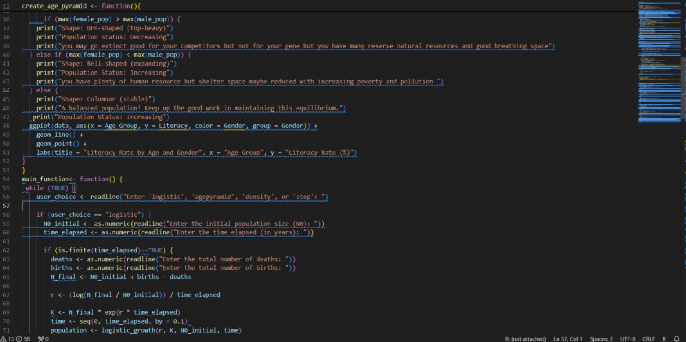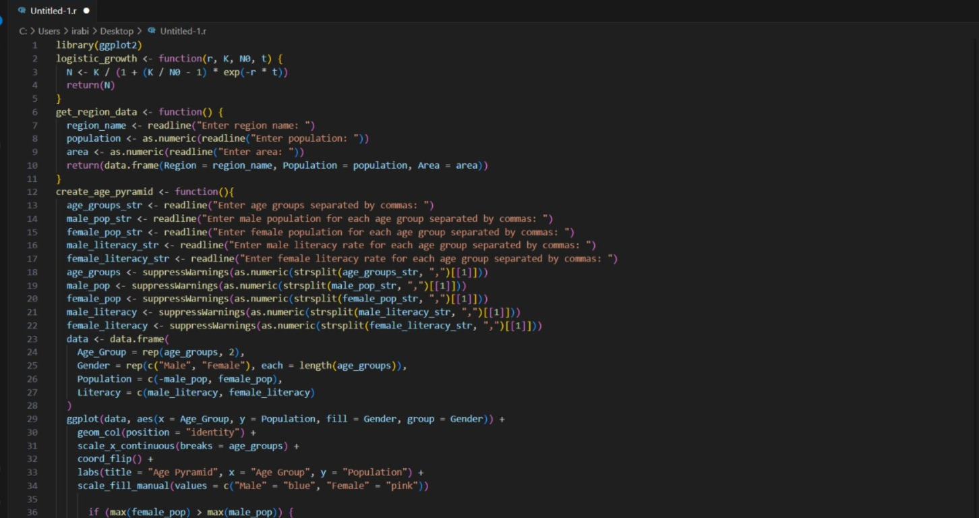

**Chapter 09**

**Testing**

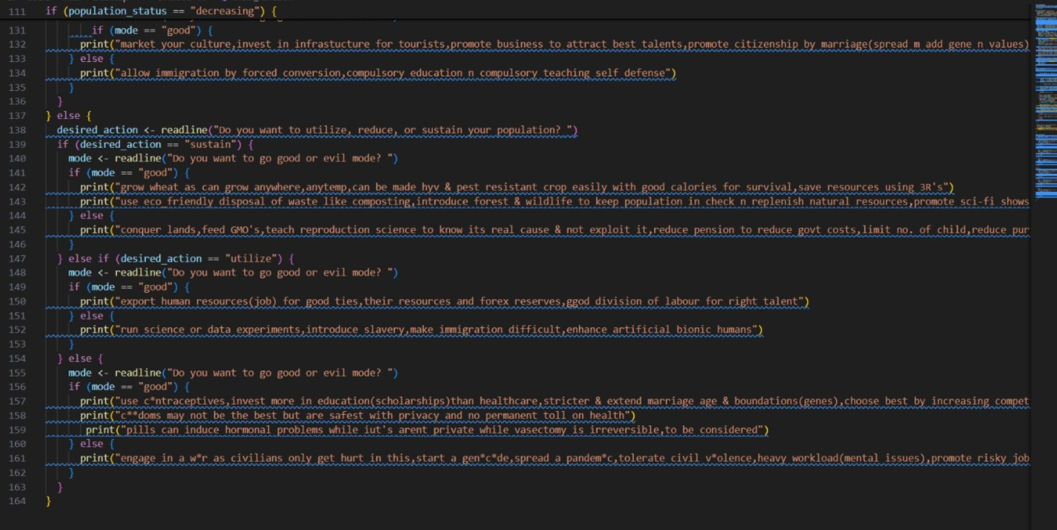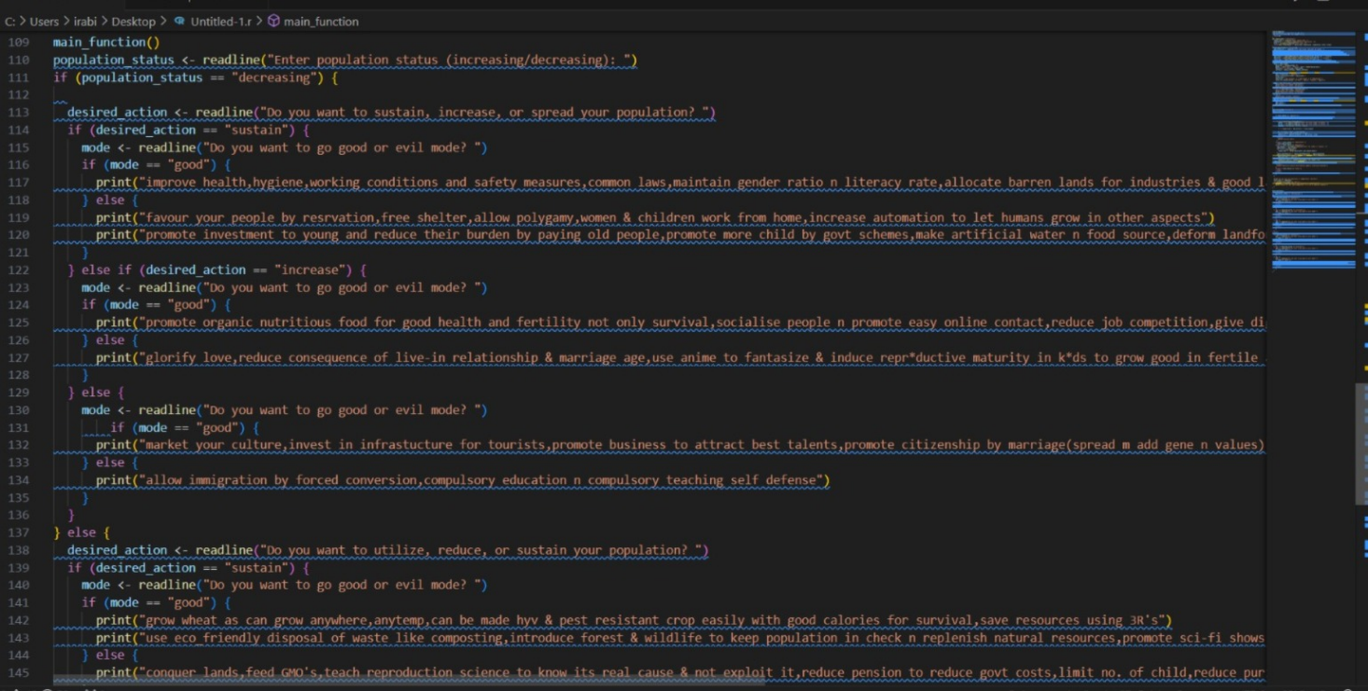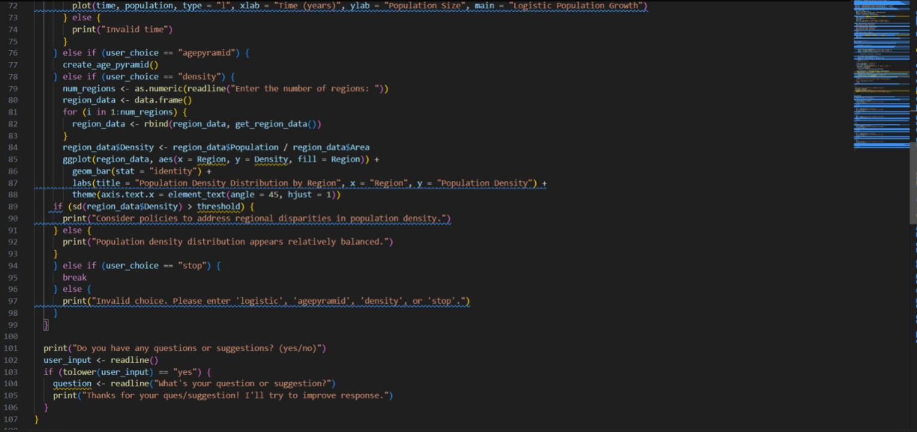

**CHAPTER NO.10**

**RESULT ANALYSIS**

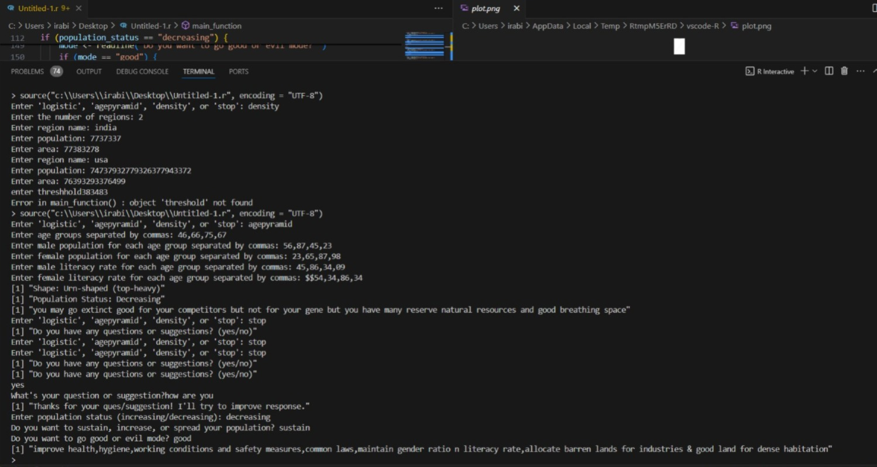

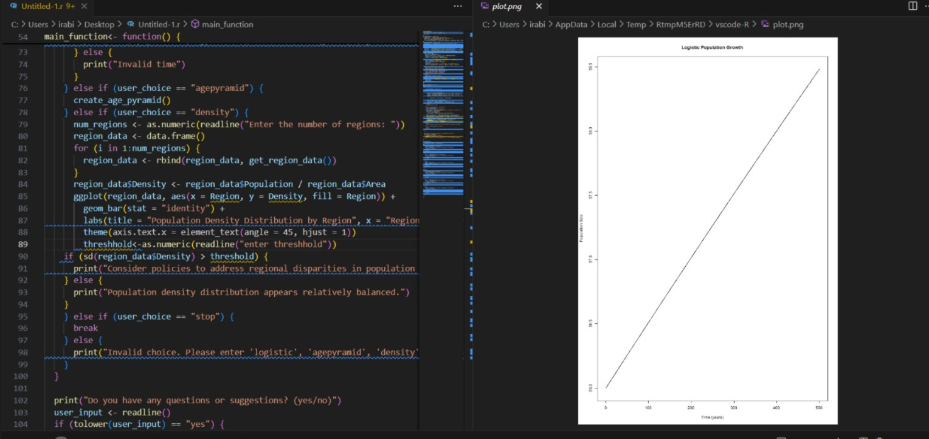

**CHAPTER NO.11**

**CONCLUSION AND FUTURE SCOPE**

**Conclusion:**

**Future Scope :This can boom in research if open sourced many researchers and academicians can contribute and extract required informations to the knowledge with supervision n monitoring from experts also individuals can be awared with it & potentially this can help businesses(B2B)to target clients but ultimately if partnered with paid from government it can reach its peak potential influencing policies of nations in our or our clients favours who pay in US like country where government influencing is ethical. For attracting individuals we would first keep free then increase price as we add functionality to system n increasing demand but give free update to them who boughtit,to respect and encourage early investment. I would like to add a scoring system to this how**

**REFERENCES**

**Book:**

# Art of R programming by Norman Maltoff

* Public Health and Epidemiology by Dr.Aruna Chakravarty n others
* Trueman Biology by K.N. Bhatia and M.P.Tyagi
* Sapiens by Yuval Noah Harari
* Tell me the answer by bluebird books
* Children’s knowledge bank
* Animal behavior by Manorama(tell me why series)
* Evolution-Manorama(tell me why series)
* World’s first-Manorama(tell me why series)
* Petroleum-Manorama(tell me why series)
* Science by m. Siraj anwar& Shweta uppal&jvnarlikar
* Junior encyclopedia by the book paradise
* Biology glossary by navneet
* Data structures by dilipkumarsultania
* Children’s world encyclopedia by Vimal Sardana and A Sunita Purushottam
* Hutchinson pocket dictionary of geography
* Wiley fundamentals of biology
* S.chand science by Lakhmirsingh& Manjit kaur
* Back from the brink by Aaditya Sengupta
* Landmark by Indira Subramaniam & Ramesh Mathur
* Economics by Shweta uppal
* Contemporary india 1&2 by hari Vasudevan & Siraj anwar
* Cambridge sociology-devyaniKapoor
* Earth mini encyclopedia by sarah Philips
* Lots more tell me how Bysunitapurushottam
* Tell me the answer by V malhotra

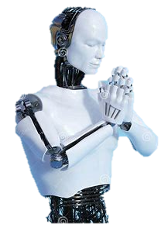

**Thank you!!**